**IMPLEMENTING THE VIEWING OF TICKET OF A PARTICULAR TRAIN**

The next task in the project is to **view ticekts of a particular train**. As usual this task is also divided in several subtasks:

1. Accept the train number with all the validations applied

2.While accepting the train no , allow the user to cancel the process in between

3.After the train no has been received , search it in the **allbookings.dat** file .

4. If train no is present , then display it's details of the tickets booked in that train otherwise print the message **NO DETAILS OF THE TRAIN NO <train no> FOUND** .

We have divided the above requirements into 3 functions:

1. **char* accept_train_no()** : This function will accept **train number** from the user with all validations applied. If the user cancels the process in between it returns **0**.

If the input is incorrect (like non existing train no) then it will display the message **Error! Invalid train no** and again ask the user to input **train number**. If the input is correct it will return the **train number**

2.**int check_train_no(char*):** This function will accept a train number as argument and check whether a train with that number exists or not. If the train exists it **return 1** otherwise it **returns 0**

3. **void view_booking(char*)**: This function will accept a **train number** as argument and display it's details by searching in the file **allbookings.dat.**

So before proceeding further make the following declarations in the header file **"rlyres.h"**

**char* accept_train_no();**

**int check_train_no(char*);**

**void view_ticket(int);**

**DESIGNING THE "accept_train_no()" FUNCTION IN THE FILE "rlyres.c"**

This function will accept **train number** from the user and will return it if it is correct . if the user cancels the process in between it **returns 0**

Following is it's prototype:

**char* accept_train_no();**

This function will do the following:

1. Prompt the user to input **train number**.

2. Run a loop which does the following:

i) accept the input

ii)if the input received is 0 then move to bottom coordinate (1,25) of the screen using **gotoxy()**, **erase the previous message** , set the color to **LIGHTRED** using **textcolor()** ,print the message "**Cancelling Input. . .**" , reset the color to **YELLOW** and return **0**.

iii) Check whether the train number is valid or not by calling the function **check_train_no()** .If the function **check_train_no()** returns 0 , it means the train number given does not exists . So move to bottom coordinate (1,25) of the screen using **gotoxy()**, , set the color to **LIGHTRED** using **textcolor()** ,print the message " **Error! Invalid train number**" , move back to coordinate (20,1) , erase the entered age and reset the color to **YELLOW** .

iv) Repeat this until **check_train_no()** returns 1.

v) After the loop is over , return the **train number**

***char * accept_train_no()***

***{***

***static char train_no[10];***

***int valid;***

***gotoxy(60,1);***

***textcolor(LIGHTGREEN);***

***printf("Press 0 to exit");***

***gotoxy(1,1);***

***textcolor(YELLOW);***

***printf("Enter train number:");***

***do***

***{***

***fflush(stdin);***

***scanf("%s",train_no);***

***if(strcmp(train_no,"0")==0)***

***{***

***textcolor(LIGHTRED);***

***gotoxy(1,25);***

***printf("\t\t\t\t\t\t\t");***

***gotoxy(1,25);***

***printf("Cancelling Input. . .!");***

***textcolor(YELLOW);***

***return NULL;***

***}***

***valid=check_train_no(train_no);***

***if(valid==0)***

***{***

***textcolor(LIGHTRED);***

***gotoxy(1,25);***

***printf("Error! Invalid Train No");***

***getch();***

***gotoxy(20,1);***

***printf("\t\t\t\t\t\t");***

***gotoxy(20,1);***

***textcolor(YELLOW);***

***}***

***}while(valid==0);***

***clrscr();***

***return train_no;***

***}***

**DESIGNING THE "view_booking()" FUNCTION IN THE FILE "rlyres.c"**

This function will search the file **allbookings.dat** and display details of all the tickets of the **train number** passed as argument to it. If the train number is not found , it will display the message **No details of the train <train number> found.**

Following is it's prototype:

**void view_booking(char* train_no)**

This function will do the following:

1. Open the file **allbookings.dat**

2.If the file is not present , it will display the message **No bookings done yet** and will return.

3. Otherwise it will **read a record from the file ,** match the train number with the argument passed and if the match is found it will display the details

4. Finally if all the records have been read and **train number** is not found then it will display the message **No details of the train <train number> found**, close the file and return.

***void view_booking(char *train_no)***

***{***

***int found=0,i;***

***FILE *fp=fopen("d:\\myproject\\allbookings.dat","rb");***

***Passenger pr;***

***printf("TICKET NO\tCLASS\tNAME\t\tGENDER\tAGE\tMOBILE NO\n");***

***for(i=1;i<=80;i++)***

***printf("-");***

***int row=3;***

***while(fread(&pr,sizeof(pr),1,fp)==1)***

***{***

***if(strcmp(pr.train_no,train_no)==0)***

***{***

***printf("%d\t\t%c\t%s",pr.ticketno,pr.p_class,pr.p_name);***

***gotoxy(41,row++);***

***printf("%c\t%d\t%s\n",pr.gender,pr.age,pr.mob_no);***

***found=1;***

***}***

***}***

***if(!found)***

***{***

***clrscr();***

***textcolor(LIGHTRED);***

***printf("\nNo details of given train no %s found!",train_no);***

***}***

***textcolor(WHITE);***

***printf("\n\nPress any key to go back to the main screen");***

***textcolor(YELLOW);***

***getch();***

***fclose(fp);***

***}***

**UPDATING THE "main()" FUNCTION**

Now finally to get this module working we will have to change the **main()** function’s

**case 6:** in **switch** statement.

Here are the steps to be done in the function **main()**:

1. Call the **accept_train_no()** function
2. Check whether the value returned by this function is **NULL** or not
3. If it is not NULL , then call the function **view_booking()** passing it the train number as argument

Here are the screenshots for this module:

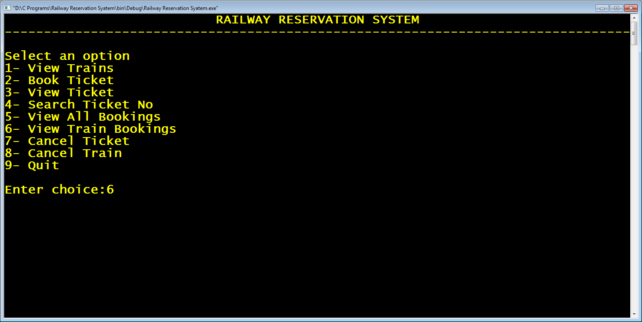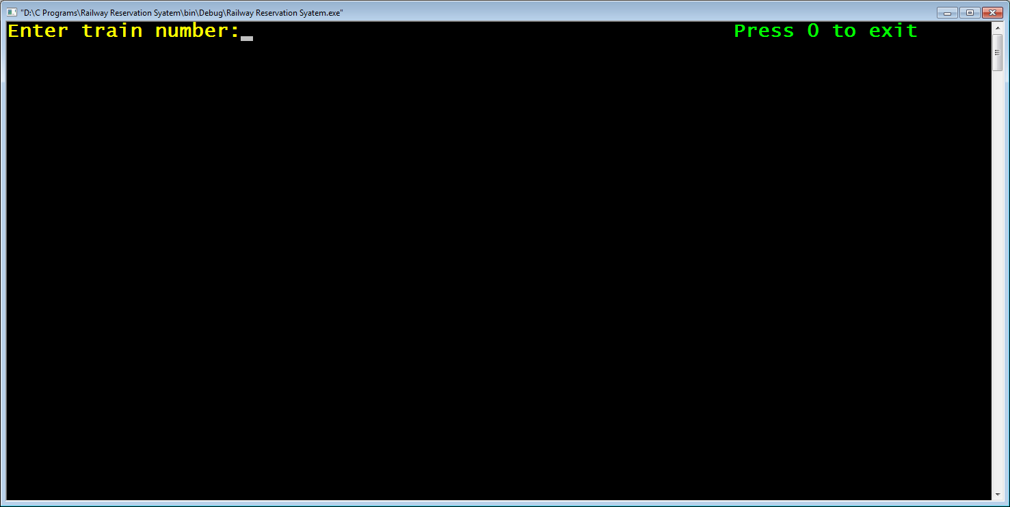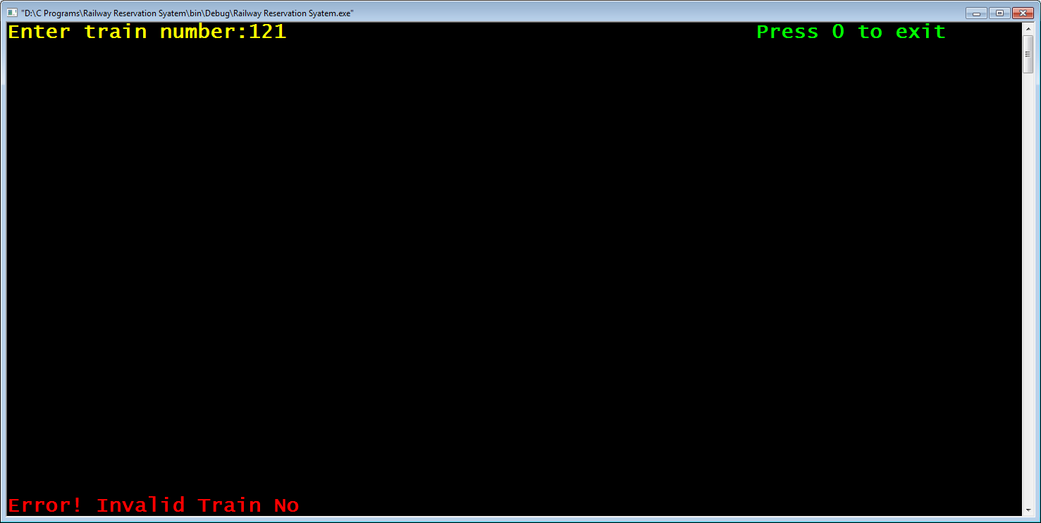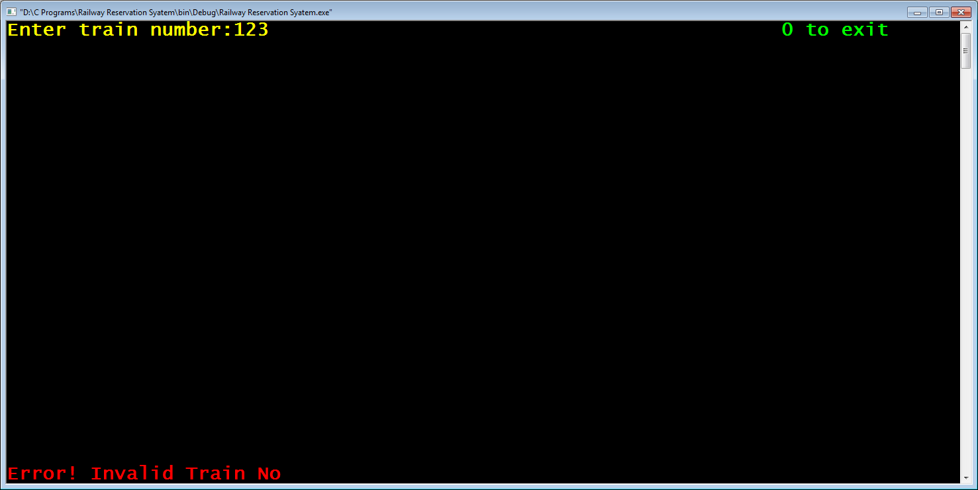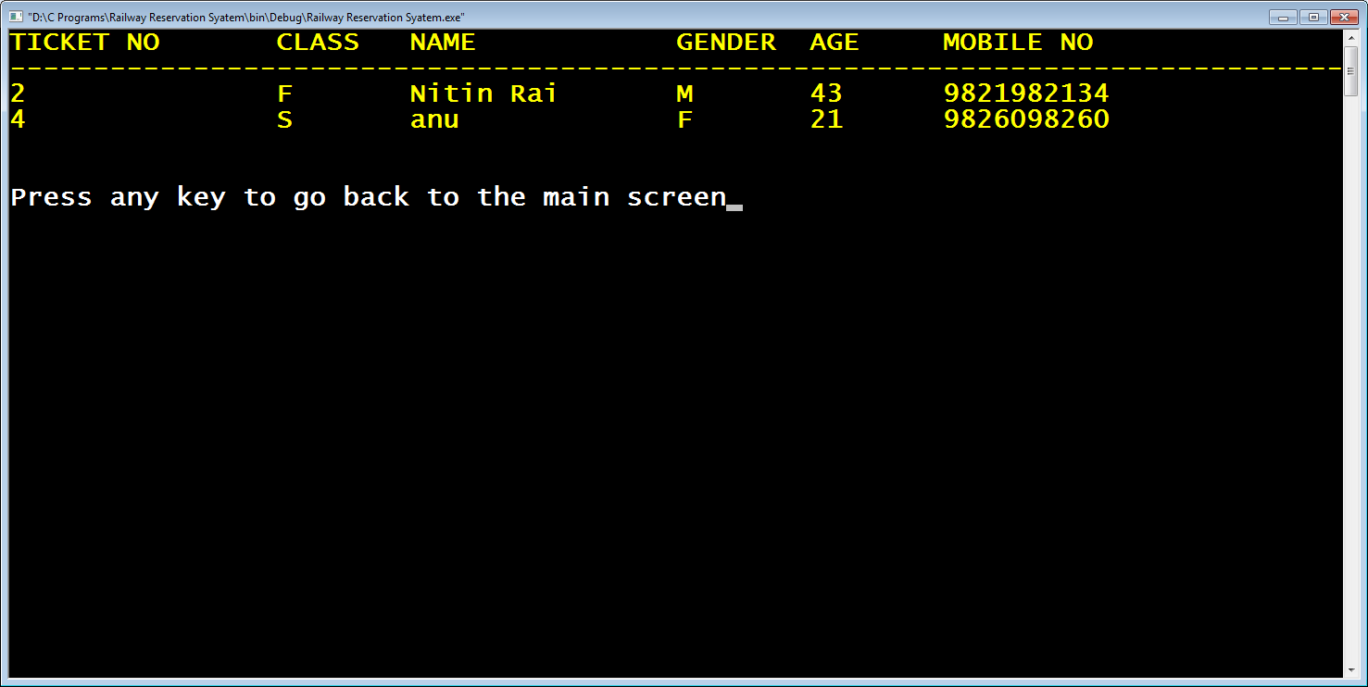

***case 6:***

***clrscr();***

***ptrain_no=accept_train_no();***

***if(ptrain_no!=NULL)***

***view_booking(ptrain_no);***

***clrscr();***

***break;***